June 2020
Dear Families of Students entering the Intermediate and Middle Grades,
This summer SKTCS will start our inaugural summer reading assignment for students entering grades 3 - 7. Read below or click on this link to find a list of books for your students. Students should choose a book within their grade band and interest area. Gifted students must choose books at their grade level or higher. Students who have an IEP may choose to read via audiobook.
You may choose to borrow books from the Live Oaks Public Library and/or purchase from a local or online ebookstore.
Choosing an appropriate book will definitely require parental discretion. As a family choose a book that will retain their interest, that they can read independently, and whose content is appropriate for their level of maturity.
The assignments for these readings are also included in the link. Students should be prepared to give their book talk at any time during the first week of school. Students who are on the more introverted side may choose to use a prerecorded presentation (i.e. - Prezi, iMovie, Powerpoint) to deliver their presentation.
If there are any questions please contact me before June 23rd (director@sktcs.org).
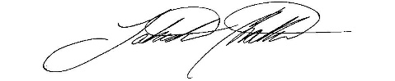
Happy Reading!!

- Dr. Chattin

Summer Reading:

- All students in grades 3 - 7 should select a book from the list below. You can purchase the book from your favorite bookstore or borrow an e-book from the public library.
- Keep a reading log of what you have read (if you need us to print this for you, please contact the school).
- On the first day of school prepare for your Book Talk (see directions and rubric below)
- Create a poster with a cause that you are committed to.

What you have to turn in on August 10th (the first day of school):
- Reading Log
- Present - Book Talk (you may decide to use an iMovie, PowerPoint, or poster to help you present your book. The more creative, the better).
- Poster illustrating a cause that you want to inform others about.

Books to Choose From

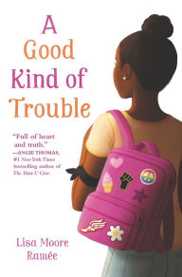

A Good Kind of Trouble, by Lisa Moore Ramée Grades 3 - 7

Trouble-averse Shayla finds herself at a powerful Black Lives Matter protest and decides to wear an armband in support of the movement, a decision that turns controversial at school. This story of a young girl’s social justice awakening demonstrates how small acts can make a big difference.

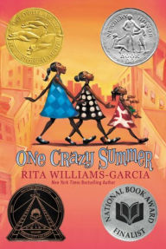

One Crazy Summer, by Rita Williams Garcia Grades 3 - 7
Set against the backdrop of the Black Panther movement, Delphine and her sisters visit their estranged mother in California, attend a Black Panther day camp, and discover their mother’s dedication to social justice issues. A moving, funny novel with a captivating voice, the sisters learn about their family and their country during one truly crazy summer.

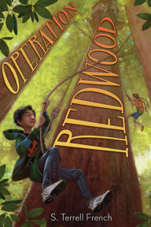
Operation Redwood, by S. Terrell French Grades 3 - 7
When Julian is sent to stay with his disinterested aunt and uncle for four months, he discovers that his Uncle’s corporation plans to cut down a group of redwood trees at Big Tree Grove and decides to take a stand to save the trees. Perfect for the young environmentalists in your life, Operation Redwood is an adventurous and gripping tale as Julian and his friends hatch scheme after scheme to save these giants of nature.
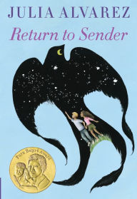
Return to Sender, by Julia Alverez Grades 3 - 7
After Tyler’s father is injured in a tractor accident, his family hires migrant workers from Mexico to save his Vermont farm. Tyler bonds with one of the worker’s daughters and navigates complicated moral choices in this award-winning novel about friendship, cooperation, and understanding.

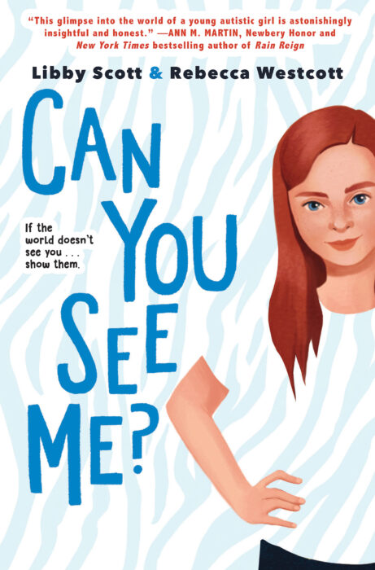

Can You See Me? Grades 3 - 7

Tally is eleven years old and she's just like her friends. Well, sometimes she is. If she tries really hard to be. Because there's something that makes Tally not the same as her friends. Something she can't cover up, no matter how hard she tries: Tally is autistic.

Tally's autism means there are things that bother her even though she wishes they didn't. It means that some people misunderstand her and feel frustrated by her.

People think that because Tally's autistic, she doesn't realise what they're thinking, but Tally sees and hears — and notices — all of it. And, honestly? That's not the easiest thing to live with.

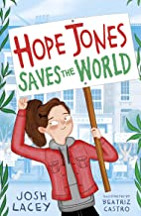
Hope Jones Saves the World. Grades 3 - 5

My name is Hope Jones. I am ten years old. I am going to save the world. Hope Jones' New Year's resolution is to give up plastic, and she's inspiring others to do the same with her website hopejonessavestheworld.com. When she realises her local supermarket seems to stock more unnecessary plastic than food, she makes it her mission to do something about it. She may be just one ten-year-old with a homemade banner, but with enough determination, maybe Hope Jones really can save the world.

Social Justice: Fifteen titles to address inequity, equality, and organizing for young readers | Great Books

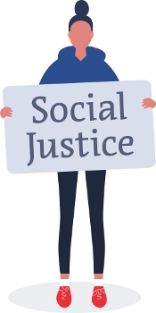
by Taylor Worley

With leaders like Greta Thunberg and Malala Yousafzai, youth are making themselves heard. These titles elevate the voices of young activists, inspire calls to action, and explain complex issues such as racism, sexism, environmentalism, and immigration. Though the books are all aimed at middle grade readers, they vary widely; the poetry and biography picks are best for younger readers, while the fiction and general nonfiction selections skew older. While far from an exhaustive list, these texts will be a strong foundation for school and public libraries serving budding activists.
We also highly recommend several books that provide further historical context, inspiration, and examples for readers: Indian No More by Charlene Willing McManis with Traci Sorell; An Indigenous People’s History of the United States for Young People by Roxanne Dunbar-Ortiz and adapted by Jean Mendoza and Debbie Reese; Kid Activists: True Tales of Childhood from Champions of Change by Robin Stevenson; The Night Diary by Veera Hiranandani;Zenobia by Morten Dürr and Lars Horneman; and You Don’t Know Everything, Jilly P! by Alex Gino.

FICTION
HARRINGTON, Kim. Revenge of the Red Club. S. & S./Aladdin. 2019. ISBN 9781534435728.
Gr 4-8– When Riley’s school suspends the students’ newspaper, imposes sexist dress codes, and shuts down the Red Club—a support group for girls dealing with menstruation—Riley and her classmates lead a revolution. Written from a cisgender perspective, this book nevertheless offers strong and inclusive messages about periods and also encourages readers to speak out.

RAMÉE, Lisa Moore. A Good Kind of Trouble. HarperCollins/Balzer + Bray. 2019. ISBN 9780062836687.
Gr 4-8 –This brilliant exploration of race and activism is ideal for readers not quite ready for Angie Thomas’s The Hate U Give. When Shayla becomes more involved with the Black Lives Matter movement after a police officer who shoots a Black man is acquitted, she must make difficult decisions about her friends, family, and school. Ramée’s writing is exceptional, and Shayla’s story will resonate.

RHODES, Jewell Parker. Ghost Boys. Little, Brown. 2018. ISBN 9780316262286.
Gr 4-8 –When 12-year-old Black tween Jerome is fatally shot by a white officer, he returns as a ghost alongside the spirit of Emmett Till and hundreds of other “ghost boys,” bearing witness to the resounding effects of his killing. Rhodes unpacks privilege, racial injustice, and implicit bias. Jerome closes the book with a thundering call to action: “Only the living can make the world better/.../Don’t let me/(or anyone else)/tell this tale again.”

WOODSON, Jacqueline. Harbor Me. Penguin/Nancy Paulsen Bks. 2018. ISBN 9780399252525.
Gr 4-7 –When a sixth grade teacher pulls a group of her students together every Friday to chat without the hovering presence of adults, Holly, Esteban, Amari, Tiago, and Ashton meet and share their experiences. Their stories and evolving relationships touch on timely topics like deportation, racism, and parental incarceration while demonstrating the need for genuine listening, discussion, and justice.

YANG, Kelly. Front Desk. Scholastic/Arthur A. Levine Bks. 2018. ISBN 9781338157796.
Gr 4-7 –When Mia Tang and her family come to the United States from China, they struggle to make ends meet and end up managing a hotel for an exploitative owner. Recognizing that other immigrants face similar difficulties, they offer them a secret safe space in the hotel. Set in the 1990s, this powerful, engaging tale of social justice explores the intersection of race, class, and immigration.

NONFICTION
CAMERINI, Valentina. Greta’s Story: The Schoolgirl Who Went on Strike To Save the Planet. tr. from Italian by Moreno Giovanni. illus. by Veronica Carratello. S. & S./Aladdin. 2019. ISBN 9781534468771.
Gr 3-6 –While Greta Thunberg’s biography to date may be brief, Camerini’s portrait of the climate activist will inspire. The author explores Thunberg’s path to activism, the support of her family, her experience with Asperger’s syndrome, and the worldwide revolution she is spearheading. Hopeful despite the serious subject matter, this work is an exemplary model for young readers eager to effect change.

GATES, Henry Louis, Jr. with Tonya Bolden. Dark Sky Rising: Reconstruction and the Dawn of Jim Crow. Scholastic Focus. 2019. ISBN 9781338262049.
Gr 6 Up –A much-needed examination of Reconstruction and the Jim Crow era, this should supplement all middle school history textbooks. Gates and Bolden look back at historical perspectives while drawing parallels to current issues of inequity and racism, illustrating how we got where we are, and emphasizing that change is imperative.

JEWELL, Tiffany. This Book Is Anti-Racist: 20 Lessons on How To Wake Up, Take Action, and Do the Work. illus. by Aurelia Durand. Quarto/Frances Lincoln. Jan. 2020. ISBN 9780711245211.
Gr 6 Up –Jewell invites readers to grab a notebook and work their way through four themed sections, with plenty of room for reflection and conversation. With an activity called “Disrupt!” the author offers suggestions for what to do if readers observe two Black men being detained by police. While Jewell acknowledges that the consequences of these actions will depend on readers’ position and privilege, she doesn’t fully explore the risks at stake. Still, there’s no substitute for this interactive guide.

RICH, KaeLyn. Girls Resist! A Guide to Activism, Leadership, and Starting a Revolution. illus. by Giulia Sagramola. Quirk. 2018. ISBN 9781683690597.
Gr 7 Up –Ready to smash the patriarchy? This robust, positive book explains how to generate change. While some of the information is best suited for young adults, there is a wealth of material for upper middle graders. Readers will learn about microaggressions, rape culture, lobbying, social pressure, and even fiduciary agents in this book that perfectly blends concept, context, and action.

YOUSAFZAI, Malala with Patricia McCormick. Malala: My Story of Standing Up for Girls’ Rights. Little, Brown. 2018. ISBN 9780316527149.
Gr 3-5 –Yousafzai’s story has been written and adapted for adults, teens, middle graders, and young children. Though appropriate for middle graders, this text doesn’t shy away from the reality of Yousafzai’s life. After learning about her work with women’s rights, her journey, and the support and education she received from her family, readers will feel that they, too, are capable of making a difference.

POETRY
BROWNE, Mahogany L. with others. Woke: A Young Poet’s Call to Justice. illus. by Theodore Taylor III. Roaring Brook. Mar. 2020. ISBN 9781250311207.
Gr 3-6 –The poems in this eloquent and instructive glossary of social justice address allyship, privilege, silencing, protest, and more, providing clear definitions and context. This short but robust title is a great classroom resource, though middle graders will also enjoy reading it cover to cover.

HUDSON, Wade & Cheryl Willis Hudson, eds. We Rise, We Resist, We Raise Our Voices. Crown. 2018. ISBN 9780525580423.
Gr 3-7 –An impressive array of authors and artists share their experiences through letters, short stories, poems, and music. Whether reading one piece at a time or cover to cover, this collection will bolster and inspire readers when the world falls short of their expectations. The topics here are complex, but never overwhelming. Those feeling hurt, confused, and lost in our persistently chaotic world will find respite here.

LATHAM, Irene & Charles Waters. Dictionary for a Better World. illus. by Mehrdokht Amini. Carolrhoda. Feb. 2020.
Gr 4 Up –Authors Latham and Waters (Can I Touch Your Hair?) tackle an alphabet’s worth of topics in this poetic dictionary: belonging, diversity, freedom, netiquette, tenacity, and zest. A “Try It” section, notes from the authors, and quotes follow each poem. Ideal for both elementary and middle school demographics.

GRAPHIC NOVELS
COLFER, Eoin & Andrew Donkin. Illegal. illus. by Giovanni Rigano. Sourcebooks. 2018. ISBN 9781492662143.
Gr 5 Up –Colfer, Donkin, and Rigano tell the story of Ebo, a young Ghanaian refugee frantically searching for his brother as both head toward Europe. The subject matter is difficult—murder and survival in horrifying conditions—but conveyed in a way that is appropriate for the target audience. This potent tale will touch readers; use it also to supplement discussions on immigration and refugee experiences.

WILLIAMS, Lily & Karen Schneemann. Go with the Flow. illus. by Lily Williams. First Second. Jan. 2020. ISBN 9781250305725.
Gr 4-8 –When the boys football team gets new uniforms (again) and the school can’t even keep the for-purchase pad and tampon dispensers stocked, four friends are roused to action. This beautiful graphic novel explores friendship, periods and the stigma against menstruation, and social justice. While the main characters are high school sophomores, the book will resonate with upper elementary and middle school students. Both the narrative and back matter normalize menstruation, and the authors acknowledge the experiences of trans and nonbinary people, albeit briefly. Amazing, period.

Student Led Booktalk

Task | Congratulations! Your teacher has just chosen you to create a booktalk for your classmates. Your goal is to get your friends and classmates hooked, or interested in reading the book you recommend in your book talk. You have an awesome responsibility. Ready to motivate others to read?
Book Talk | A booktalk is a 2-5 minute talk about a book you want to motivate others to read. It is similar to a movie trailer but for books. The purpose of a booktalk is to "sell" the book like an advertisement. You want to give enough information about the text to interest the listeners but you are not giving a summary of the book. You don't want to give away the important parts of the book. You certainly never want to give away the ending. You want to highlight the interesting points. You may want to read certain passages to your listeners. The main purpose of a booktalk is to grab the audience's interest and make them want to read the book. It's always a good idea to end the booktalk with a cliffhanger. The booktalker presents the booktalk orally and usually has the book as a visual prop.
Essential Question | How can I get people in my class hooked a good book?
Product | Your mission is to create an exciting booktalk.  To begin, you must:  · First, think about what gets you excited about reading. Is it the characters? Or is it the setting, an exciting plot, interesting themes, or a personal connection you have with the story? Do you like to read about our world through nonfiction?  · Second, find a great book to share.  · Third, prepare the attached booktalk form to help you prepare for the talk. Use the notes from your Summer Reading Log to remind you of the details.  · Fourth, prepare an exciting script for your booktalk by:  1. Including an interesting hook.  2. Thoroughly and vividly describing the text by using interesting words.  3. Explain how the text can be connected to the listeners in the class.  4. Retelling an exciting part of the story without giving away too much information to ruin it.  5. Using props where appropriate to build interest.  6. Restating the title and author at the end of your booktalk.  7. Leaving your listeners with a compelling reason for checking out the book you recommended.  · Fifth, deliver your booktalk to your audience. Remember to:  1. Speak loudly and clearly.  2. Make frequent eye contact with your audience.  3. Speak with enthusiasm. Remember it’s your job to hook your reader.
Assessment | You will be graded using the BookTalk Rubric.

Booktalk Student Checklist
Guiding Questions | Yes? | No?
Am I prepared to explain why this book is at my appropriate level?
Did I remember to include the title, author and genre?
Did I include several specific details about the book?
Did I make a connection to share with my peers?
Have I prepared a hook to begin the talk?
Am I ready to retell an exciting part of the text?
Am I prepared to restate the title, author and genre in my conclusion?
Am I prepared to share a strong reason for the audience to read the book?
Have I practiced at least 3 times (at least once in front of someone else)?

Student Led Book Talk Rubric
Student Name: ________________________ Homeroom Teacher _______________
CATEGORY | 3 | 2 | 1 | Notes to applaud or improve
Attention  getter!! | Creative attention getter! The audience was hooked! | Average introduction. No real hook! | Introduction was missing! No attempt to hook the audience.
Title, Author,  Genre | I told the title, the author, and what type of book it is. | I only told 2 of these 3 things. I left one out. | I only told 1 of these things or I told none of them.
Main character  and his/her  importance in  the story | My description of the character was VIVID and provided traits and explanation of his/her importance inthe story. | My description of the character was AVERAGE and I did not provide an explanation of his/her importance. | I did not describe my character or provide any explanation of his/her importance.
Interesting  facts/Important  Events | I provided at least 3 interesting facts or mportant events from the story. | I provided only 2 interesting facts or important events from the story. | I provided only 1 or no interesting facts or important events from the story.
Star Rating | I provided a star rating (1-5) and I gave a convincing reason for my rating. | I provided a star rating, but gave no reason for it. | I did not provide a star rating.
Voice | My voice was clear,strong and enthusiastic. | My voice was clear and strong, but not enthusiastic. | I was hard to hear or understand.
Eye contact | I maintained eye contact with my audience. | I had to look back at my notes several times. | I read from my notes the whole time.
Time for  Presentation | My book talk lasted between 2 - 5 minutes | My book talk was between 1 min. to 30  seconds. | My book talk was less than 30 seconds long.
Appropriate  Book | Student chose a book that is at appropriate reading level. | Student chose a book that is close to his/her reading level. | Student chose a book that is below his/her reading level.

FINAL GRADE _____/ 27 = ______________

