July 29, 2020

Dear Families,
We hope you are faring well. Hard to believe that we are just three weeks out from the start of school. A gentle reminder that SKTCS is on a different schedule than SCCPSS. Our students will start back for virtual learning on Monday August 17th at 9 am. You will receive more detailed instructions about schedules, school supplies, and expectations once teachers are back to work. Please remember to look-out for information from SKTCS. You can disregard information sent from SCCPSS.

School Supplies
Although we had school supply lists all ready for you, Covid has, of course, thrown us for a loop. Once teachers are back in the building next week we will revise and disseminate the school supply lists for Face-to-face instruction.
For now, all students should have the following materials for virtual instruction:
- K - 5: An 11 inch neoprene carrying sleeve/bag for Chromebooks (mandatory for students borrowing a school device). Like this one found at Amazon:
- 6 & 7th grade: A 14 inch neoprene carrying sleeve/bag for Chromebooks (mandatory for students borrowing a school device). Like this one found at Amazon:
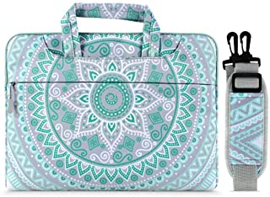

- Blue Blocker Glasses (optional, but they are good for reducing strain from looking at a computer screen):
- A Notebook
- Pencils and erasers
- Crayons
- Headphones with a microphone like these found at Amazon (or the headphones that come with iPhones): https://www.amazon.com/Mpow-Headphones-Foldable-Comfortable-Earphones/dp/B07RSJX4KW/ref=sr_1_8?dchild=1&keywords=headphones+with+microphone+for+kids&qid=1596047593&sr=8-8

Again, once teachers are back in the building we will share more specific supply lists.

Technology Distribution
Families will be notified when they can come and pick up resources (Computers and Workbooks) for students. Please stay tuned to your email for further details.

Finally, email will be our primary mode of communication (you can delete the Bloomz app!). We will share information as we are able and as always, we thank you for your patience and understanding during these times.
Yours in Service,
Dr. Chattin

