Family Engagement Policy
2020 – 2021
(August 12, 2020)
Dr. Latrisha Chattin, School Director  1709 Bull St. Savannah, GA 31401  Phone: (912) 395-4200  Fax: (912) 201-5265 www.sktcs.org  Our Mission  A community, not just a school. We seek to cultivate a vibrant, academically challenging learning community that celebrates each individual's gifts and instills in students a sense of stewardship as members of the Savannah community and as citizens of the world. | What is Title I?  Title I, Part A of the Elementary and Secondary Education Acts, as amended by the Every Student Succeeds Act (ESSA) provide financial assistance to local educational agencies and school with high numbers or high percentages of children from low-income families to help ensure that all children meet challenging state academic standards.  Title I is designed to support State and local school reform efforts tied to challenging state academic standards and reinforce and enhance efforts to improve teaching and learning for students. Title I programs must be based on effective means of improving student achievement and include strategies to support family involvement. All Title I schools must jointly develop a written family engagement policy with all families.  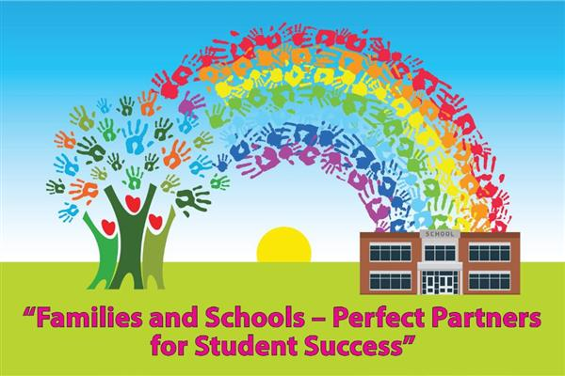

What is Family Engagement?  Family engagement means the participation of families in regular two-way and meaningful communication involving student academic learning and other school activities, including making sure:  * That families play a role in assisting their child’s learning.  * That families are encouraged to be actively involved in their  child’s education.  * That families are full partners in their child’s education and are  included, as appropriate, in decision making and on committees  to assist in the education of their child.  * The carrying out of other activities, such as those outlined in  Section 116 of the Every Student Succeeds Act (ESSA).  How it was revised?  SKTCS Family Engagement Policy was formulated using information gained through surveys administered during the school year and feedback from families.  Who is it for?  Students participating in the Title 1, Part A program, and their families are encouraged to fully participate in the opportunities described in this policy. In October, the school will convene the Annual Title 1 Meeting ti inform families of the requirements of Title 1, the school’s participation and the parent’s right to be involved.  Where is it available?  The policy can be found on the Title 1 tab located on our school’s website.  A School that Mirrors our Community  We feel that a multicultural and socioeconomically diverse school community creates an enriched learning environment through the exploration, understanding, and appreciation of differences.  SKTCS will take the following measures to promote and support families as a vital foundation of the school in order to strengthen the school ad reach our goals. We will:  - Ensure that all information related to school and family programs, meetings, and other activities are posted on the school website, through texts, social media and included in newsletters for all families.  - Share information with families about the school’s academic standards (Georgia Standards of Excellence) and assessments (Georgia Milestones and MAP) as well as ways in which parents can monitor their child’s progress.  - Resources will be provided to assist students with grade level work, improving reading and math skills.  - Collect feedback from families at all events and post email contact info for family suggestions on the school’s website in order to respond to families’ requests for additional support for family engagement activities.  - Teachers, instructional support staff, director and other school staff will be training throughout the year on topics including the value and utility of contributions of families, how to reach out to, communicate with and work with families as equal partners. Additional they will be trained on how to implement and coordinate family programs that help build connections between school, home and community. |  | What is a  Family/Parent-School Compact?  A Family/Parent-School Compact is an agreement that explains how parents and teachers will work together to make sure all our students reach grade-level standards. It provides strategies to help connect learning at school and at home. The compact will be reviewed and updated annually based on feedback from parents, students and teachers collected through surveys and forums. Compacts will be available in August of each school year. Compacts will be utilized at family conferences as well.  Jointly Developed  A Family Forum is held to review and revise the compact based on the school’s academic achievement goals and students’ needs.  Parents are welcome to provide feedback on the compact at any time during the school year. Please contact Dr. Chattin at latrisha.chattin@sktcs.org or at 912-395-4200. You may also visit sktcs.org and click on the Title 1 tab for more information.  Our Vision  We hope to foster compassionate, curious, creative, and confident global citizens who are stewards of truth-seeking, simplicity, integrity, community, and equal respect for all.  Our Model  We leave traditional textbooks and basal behind. We draw from the resources of our natural surroundings and use our neighbors' skills and talents to enhance our classroom learning
Our Vision  We hope to foster compassionate, curious, creative, and confident global citizens who are stewards of truth-seeking, simplicity, integrity, community, and equal respect for all.  ​  Important Academic Dates:  Progress Reports Issued  September 18  November 13  February 5  April 23  Report Cards Issued  October 16  December 18  March 19  May 28  Benchmark Assessment Windows  August-September  December -January  April-May  GMAS – April | SKT Family Engagement  Calendar  2020-2021*  - August: Compact and Family Policy distributed  - October: Annual Title I Meeting to inform parents of the requirements of Title 1 and the school’s participation as well as parent’s rights under Title 1.  - October-March: Inform families about assessments, promotion requirements and other support as requested  - November: National Family Engagement Month  - April: Annual Surveys go home, meetings to get input and feedback on Compacts, family Policies, 1% Family Engagement Budget and School Improvement Plans to prepare for the upcoming school year.  *Event/Workshop dates may be  subject to change.  **Additional events will be scheduled  throughout the year.  ***Families/Parents may request meetings on various topics which will be addressed as possible through the existing schedule or by additional times and dates  ****Families will be notified of all events at least two  weeks in advance.  